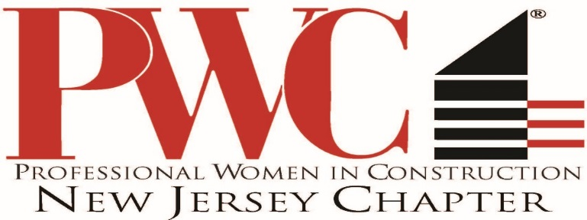
February 28, 2018

Dear Christine:
Congratulations! You have been selected by the New Jersey Chapter of Professional Women in Construction to receive the distinguished 2018 WOMEN OF ACHIEVEMENT AWARD.

The goal of the non-profit NJPWC is to provide educational, networking and mentoring opportunities to women and WBE entities in the construction industry.

The Women of Achievement Award is given to those individuals who have realized significant success in the construction industry. Based on a review of your roles and accomplishments by the NJPWC Board of Directors, we believe you are the perfect candidate for the award this year.

The 2018 recipients of the Women of Achievement Award are an outstanding group of female professionals. A complete list of all awardees and their bios will be distributed to each of you in the next few weeks.

The Women of Achievement awards will be presented at a luncheon to be held this year on March 21st at the Liberty House Restaurant in Jersey City, NJ from 11:00am-2:30pm. We ask each awardee to attend the luncheon and give a 10-15 minute presentation on your personal success story and any advice you can offer to your fellow female professionals in the construction industry.

A key component of the Women of Achievement event is our ad journal. Please provide me with a photo along with a short resume or bio in JPEG format to include in this year’s journal by March 5th. The PWC would be happy to contact any individuals and/or organizations that might be interested in showing support of your nomination for this award either through attendance at the luncheon or by placing an ad in our event journal. If you would like us to contact your supporters directly, please provide an Excel spreadsheet including all names, organization names and e-mail addresses.

All proceeds from this year’s Women of Achievement event will be utilized to fund the Professional Women in Construction Scholarship Fund. The PWC Scholarship Fund was established to support female students interested in pursuing a degree in a construction related field.

We will communicate more specific event information by the end of next week and provide each awardee with a framework for your presentation at the March 21st luncheon. In the meantime, congratulations again and thank you for your support and participation in the NJ Chapter of Professional Women in Construction. If you have any questions, please don’t hesitate to contact me directly.

Sincerely,
Lisa E Chowansky
Lisa E Chowansky
Vice-President PWCNJ
908-534-3833 X702

